Scenario Brief — Lesson Plan
Classification: UNCLASSIFIED

1. Administrative and metadata

1.1 Lesson title
Scenario Brief

1.2 Module length
45 minutes (0.75 hours)
Copied from content-guide Duration (~45 minutes). Not on the pilot delivery sheet.

1.3 Terminal and enabling learning objectives
- TLO-1: At the end of the Counterstrike Operator Course, students will possess the ability to conduct military tactical planning in the context of DCO-RA
- ELO-78: Identify operational-environment elements that will impact planned operations.

1.4 Prerequisites
- B01.M01: Course Introduction

2. Personnel, range, and environment

2.1 Instructor and cadre
- 1 × instructor (required)
- 0 × range_engineer (not_applicable: Lecture Module; no range engineer required)
- 0 × auditor (not_applicable: Not used by this course)
- 0 × oversight_officer (not_applicable: Not used by this course)

2.2 Materials and resources
Instructor resources and pre-class preparation
- Classroom projector and screen
- Whiteboard and markers (two-state sketch for the opening; capture targeting answers on Slide 8)
- Instructor copies of ../../scenario/index.md, ../../scenario/overview/background.md, ../../scenario/overview/varensk.md, and ../../scenario/overview/lunovia.md
- Project ../../scenario/maps/network-diagram.png full-screen on Slide 10
Student resources and environment
- Student copies of the scenario overview pages listed above
- Course network diagram at ../../scenario/maps/network-diagram.png
- No additional student kit for this lecture

3. Assessment and evaluation
ELO | Method | Related Module | Criteria
ELO-78 | in-class Q&A | — | Students identify Varensk and Lunovia environment elements that will impact later planning.

4. Instructional delivery

4.1 Opening, attention grabber, and motivator

Option 1 (Interactive / Whiteboard / Kinesthetic)
- Say: "Before we get into the scenario itself — why fictional? Two reasons. First, classification: a fictional scenario keeps us out of problems during training. Second, common ground: every student, every block, every lab will share this world."
- Do: Sketch two neighboring states on the board (large authoritarian state, smaller democratic state, border between them). No real-world place names. Leave the sketch up.
- Ask (Q): Who has taken a course that used a real-world actor as the scenario and hit a classification wall mid-lab?
- Expected Response (A): Facilitation only. Hands are the point. Do not collect a scored answer.

Option 2 (Digital Slide / Virtual / Slide Deck)
- Say: "Before we get into the scenario itself — why fictional? Two reasons. First, classification: a fictional scenario keeps us out of problems during training. Second, common ground: every student, every block, every lab will share this world. When I say 'Varensk,' you will know what I mean for the rest of the course."
- Show: The regional map graphic (two unnamed states; no real-world place names).
- Do: Keep the classification-wall check as a verbal show of hands if a whiteboard is not available.
- Ask (Q): Who has taken a course that used a real-world actor as the scenario and hit a classification wall mid-lab?
- Expected Response (A): Facilitation only. Hands are the point.

4.2 Side-by-side table of instruction
Visual / Slide Asset | Instructional Delivery & Instructor Notes
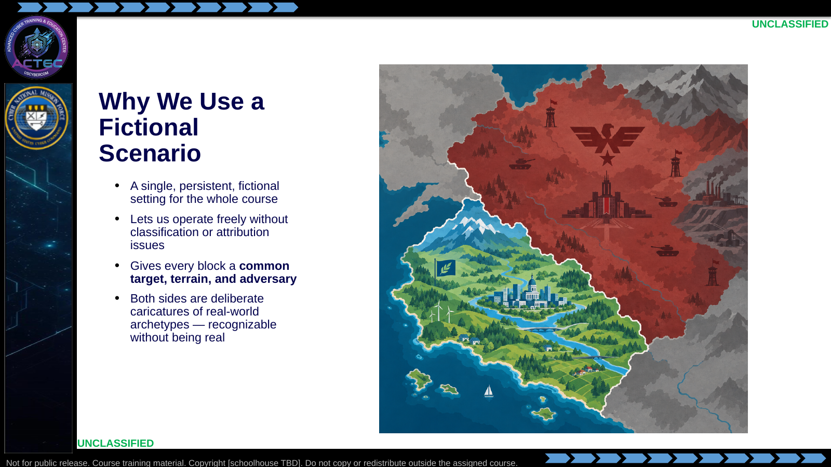  Slide 1: Why We Use a Fictional Scenario  Duration: 3 min | Say: "Before we get into the scenario itself — why fictional? Two reasons. First, classification: a fictional scenario keeps us out of problems during training. Second, common ground: every student, every block, every lab will share this world. When I say 'Varensk,' you will know what I mean for the rest of the course."  Show: The regional map graphic.  Do: Take a show of hands. The hands are the point.  Ask (Q): Who has taken a course that used a real-world actor as the scenario and hit a classification wall mid-lab?  Expected Response (A): Facilitation only. Hands, not a scored answer.
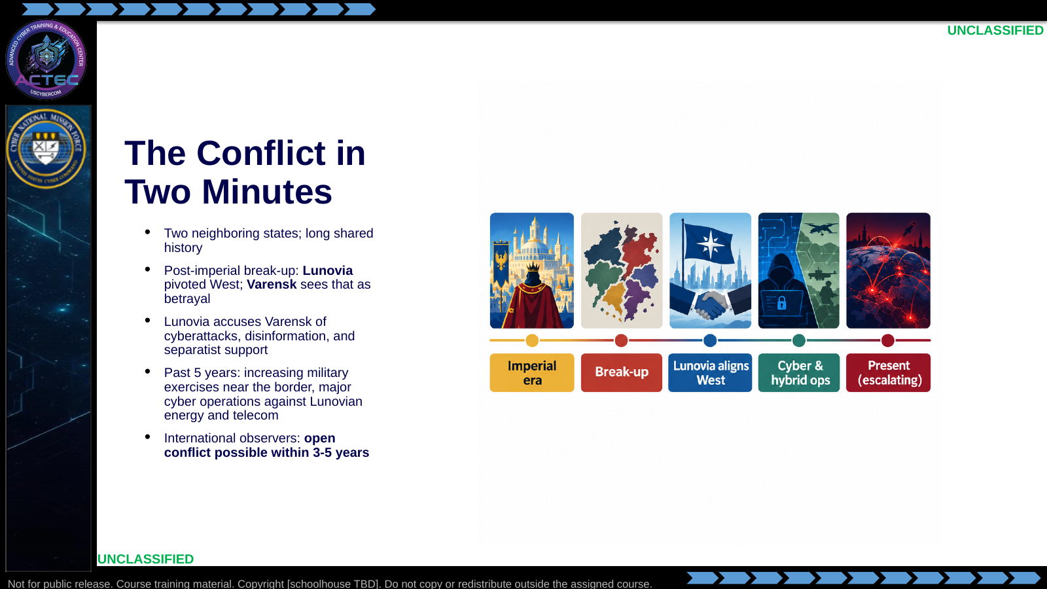  Slide 2: The Conflict in Two Minutes  Duration: 4 min | Say: "Here is the backstory in a paragraph. Two neighboring states, long shared history. When the old empire broke up, Lunovia went West. Varensk treats that as betrayal. Over the past five years, the border has heated up and Varensk has run cyber and hybrid operations against Lunovia's critical infrastructure. International observers expect open conflict in 3 to 5 years."  Show: The timeline graphic.  Do: Let the room call out parallels, then steer back to the scenario names.  Ask (Q): What real-world parallels do you hear in this backstory?  Expected Response (A): Facilitation only. Acknowledge parallels, then steer back: "We operate in Varensk vs. Lunovia for the rest of the course."
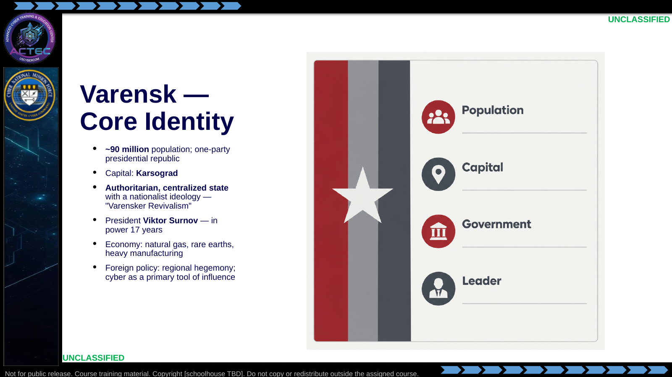  Slide 3: Varensk — Core Identity  Duration: 4 min | Say: "Varensk is the big one. Ninety million people, centralized authoritarian government, a nationalist ideology called Varensker Revivalism. The president has been in power 17 years. Economy runs on gas, rare earths, and heavy industry. Their foreign policy is regional dominance and they treat cyber as a primary lever."  Show: The country-profile card.  Do: Let the room answer — it seeds the cyber-apparatus discussion two slides from now.  Ask (Q): If you were in their intelligence service, what would your job priorities be?  Expected Response (A): Facilitation only. Steer toward influence, espionage, and infrastructure pressure. Do not require a unit name yet.
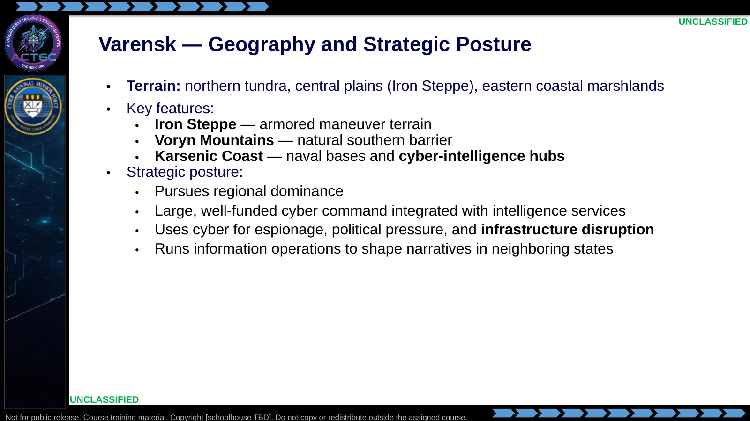  Slide 4: Varensk — Geography and Strategic Posture  Duration: 4 min | Say: "Physical geography matters even in a cyber course. The Karsenic Coast hosts their naval bases and their cyber-intelligence hubs. That co-location is realistic — in the real world, signals and cyber infrastructure cluster near the sea and near the core."  Show: The bullet list; linger on Karsenic Coast.  Do: Tie back: "When we plan against Varensk in later blocks, 'location' on your SALUTE is going to point here."  Ask (Q): When we plan against Varensk later, where does SALUTE location point on this map?  Expected Response (A): Steer toward the Karsenic Coast (naval bases and cyber-intelligence hubs).
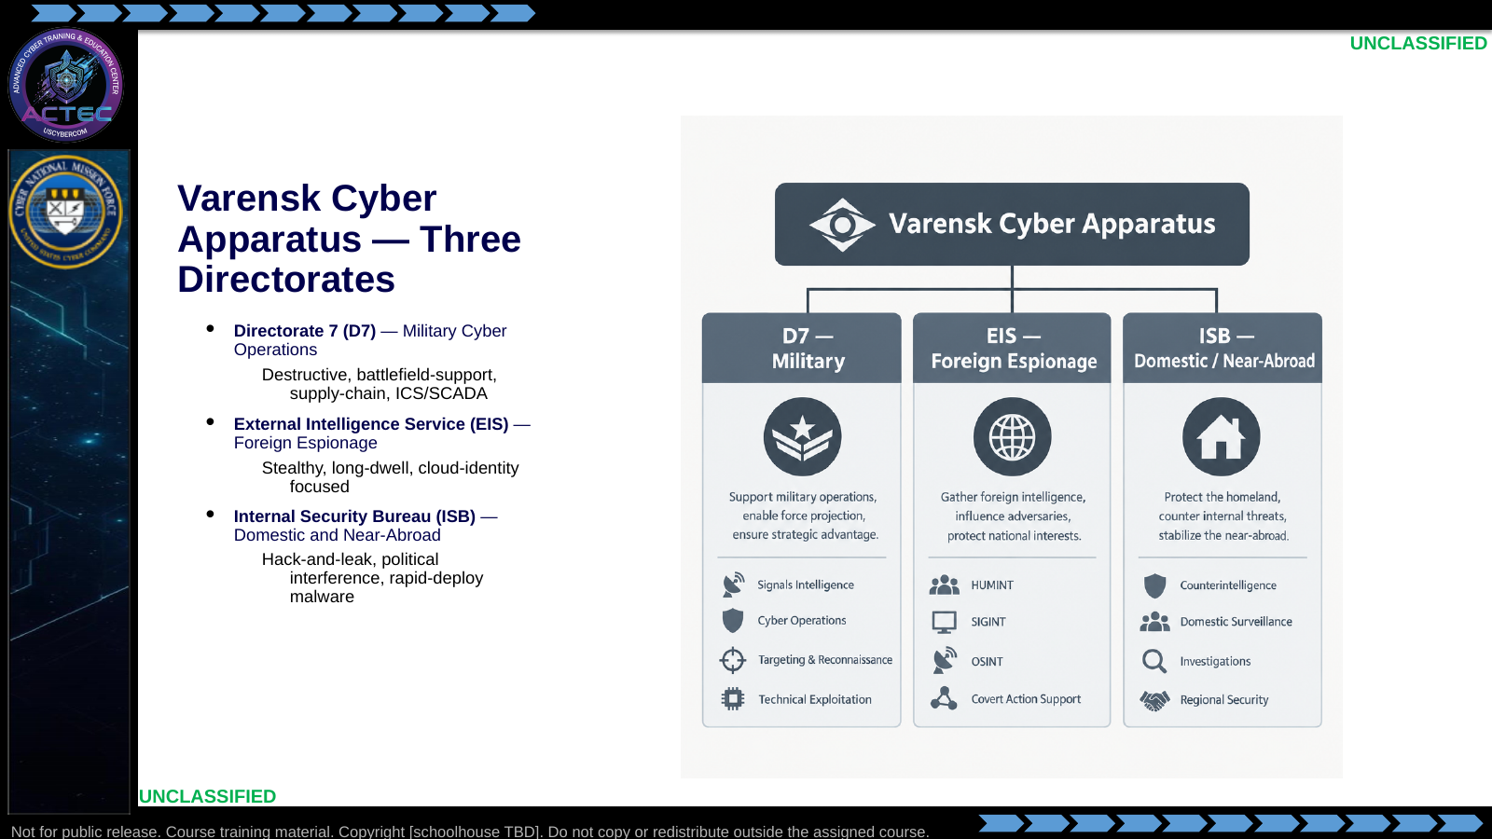  Slide 5: Varensk Cyber Apparatus — Three Directorates  Duration: 4 min | Say: "Varensk's cyber apparatus has three directorates. D7 is the military cyber arm — the destructive one. EIS is foreign espionage — the stealthy one. ISB is domestic and near-abroad — the loud, politically-driven one. When we plan against a specific actor in this course, you will trace them back to one of these three."  Show: The three-column diagram.  Do: Preview: the next slide breaks each directorate into specific units.  Ask (Q): Which directorate is destructive, which is stealthy, and which is politically loud?  Expected Response (A): D7 destructive; EIS stealthy; ISB politically loud / hack-and-leak.
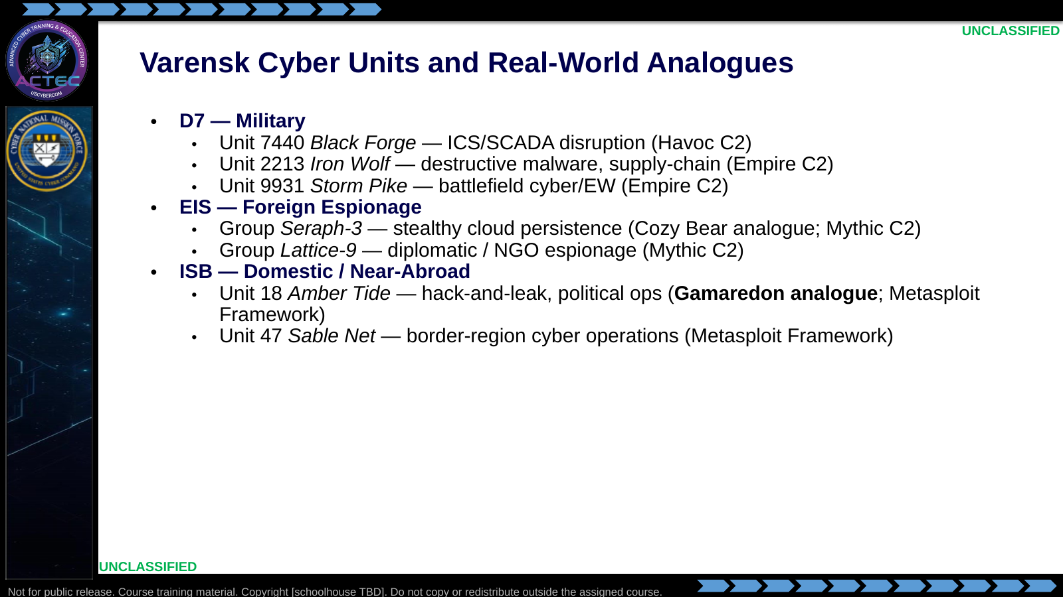  Slide 6: Varensk Cyber Units and Real-World Analogues  Duration: 5 min | Say: "Here is the unit-level detail. Pay attention to the C2 framework assignments — they are intentional and consistent through the course labs. Also note the real-world analogues in parentheses: Seraph-3 plays the Cozy Bear role; Amber Tide plays the Gamaredon role. When we do the Gamaredon walk-through in Block 2 and the labs use Amber Tide instead — that is the reason."  Show: The unit list; point specifically to Unit 18 Amber Tide and note its Gamaredon role.  Do: Tell students to dog-ear this slide. They will return to it every time the course names a Varensk unit.  Ask (Q): Which Varensk unit plays the Gamaredon role in this course, and which plays Cozy Bear?  Expected Response (A): Amber Tide (Unit 18) = Gamaredon; Seraph-3 = Cozy Bear.
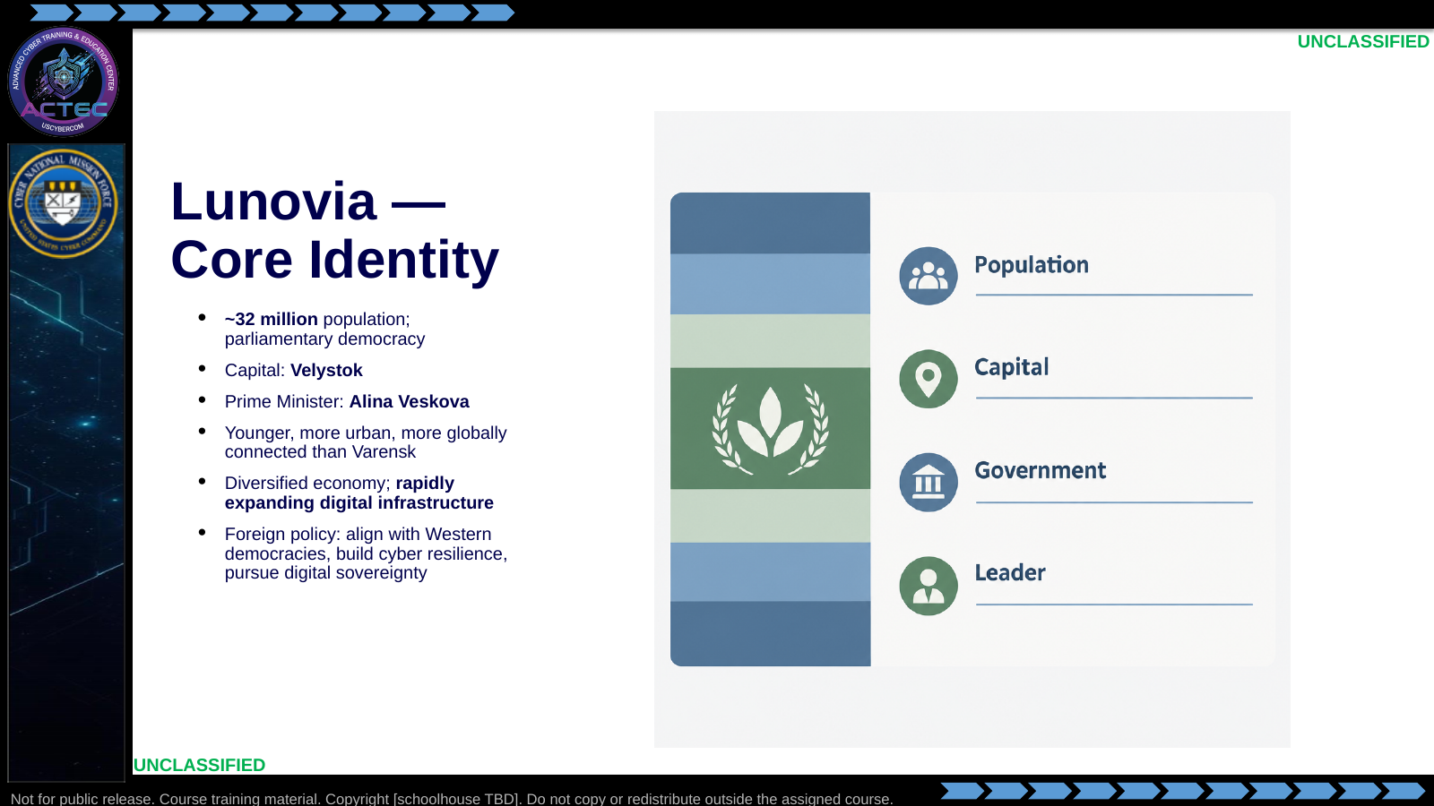  Slide 7: Lunovia — Core Identity  Duration: 4 min | Say: "Lunovia is the smaller, democratic state. Thirty-two million people, parliamentary republic, younger and more urban than Varensk. Their economy is diversified and digital. Their foreign policy is Western alignment, cyber resilience, digital sovereignty. In short — they look like the state we usually find ourselves defending."  Show: The country-profile card.  Do: Draw the parallel explicitly. Get a nod of understanding from the room.  Ask (Q): When we are the blue team, who are we in this scenario? When we plan DCO-RA out of blue-space, who are we?  Expected Response (A): Blue team = Lunovia. DCO-RA out of blue-space = a Lunovian unit.
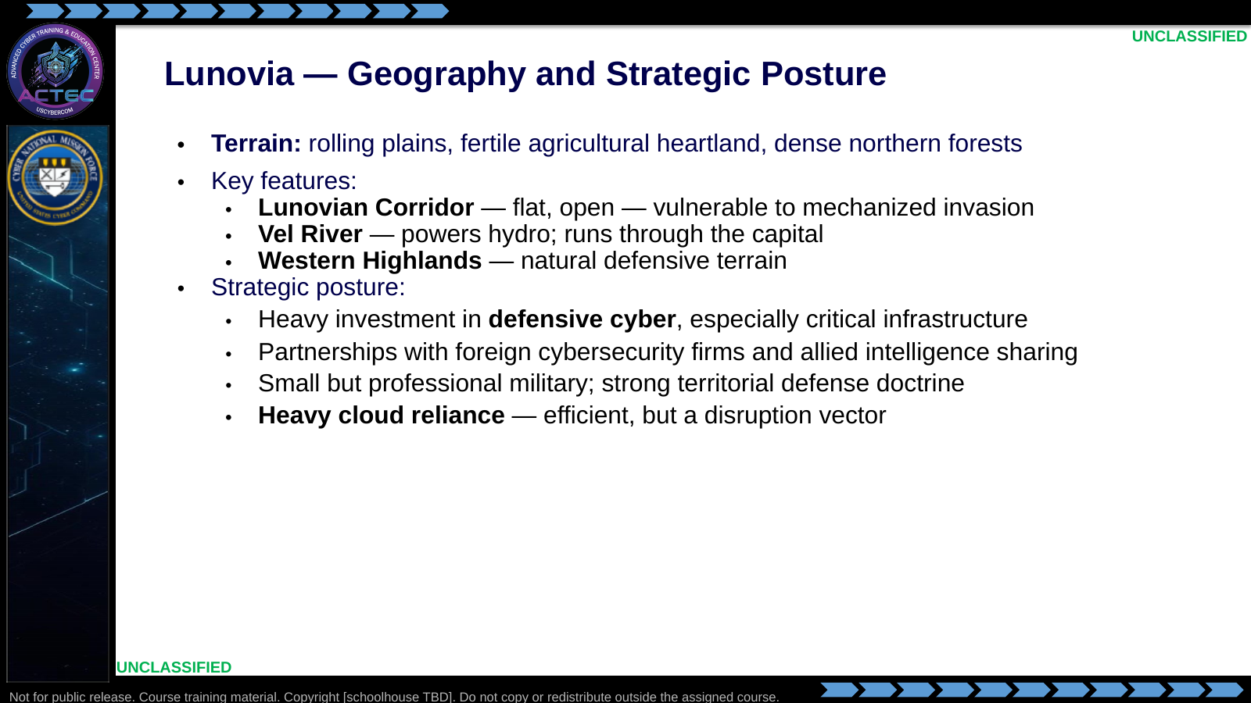  Slide 8: Lunovia — Geography and Strategic Posture  Duration: 4 min | Say: "Lunovia's strategic posture is exactly where a lot of real-world partner nations sit — heavy investment in defensive cyber, lots of allied partnerships, strong territorial defense, and a cloud-heavy digital government. That cloud reliance is efficient, but it is also an attack surface we will revisit."  Show: The bullets; linger on the last sub-bullet (cloud reliance).  Do: Capture two or three answers on the board.  Ask (Q): Name one thing you would target first if you were Varensk and you wanted to rattle Lunovia without triggering a kinetic response.  Expected Response (A): Facilitation only. Cloud, energy, telecom, or hydro on the Vel River are on-scenario. Do not grade a single correct target.
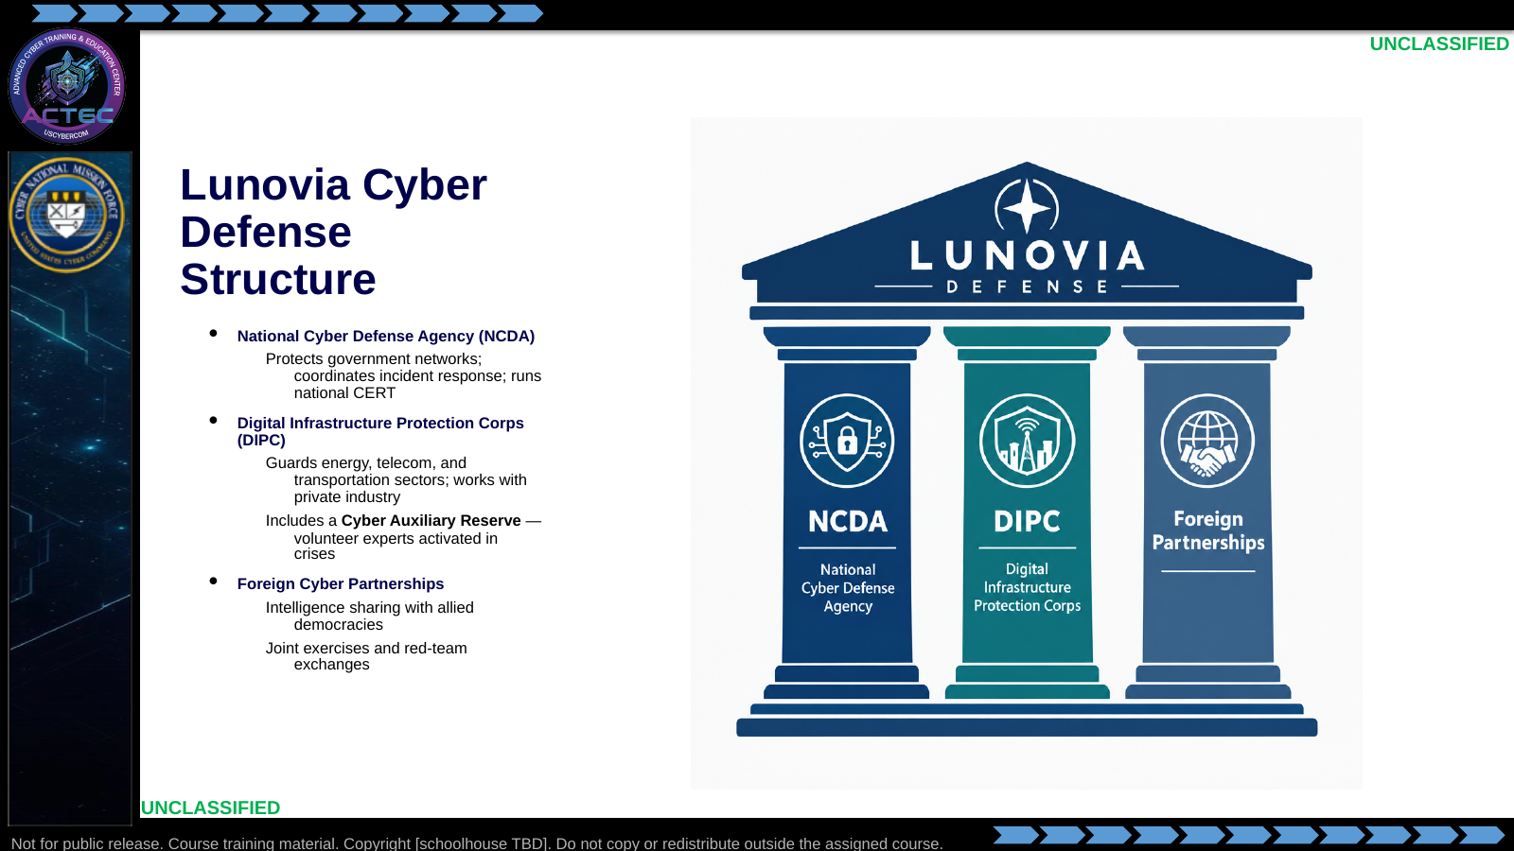  Slide 9: Lunovia Cyber Defense Structure  Duration: 4 min | Say: "Lunovia's defensive cyber structure has three pillars. NCDA runs the CERT and defends government networks. DIPC guards critical infrastructure sectors and includes a volunteer cyber auxiliary. And their foreign partnerships provide intelligence sharing and joint exercises. If you are playing blue, you are probably in NCDA or DIPC."  Show: The three-pillar diagram.  Do: Use the answers to set CPT assignment lanes (NCDA or DIPC).  Ask (Q): Which Lunovian pillar would you most likely be assigned to as CPT operators?  Expected Response (A): Facilitation only. NCDA or DIPC are the expected lanes from the Say script.
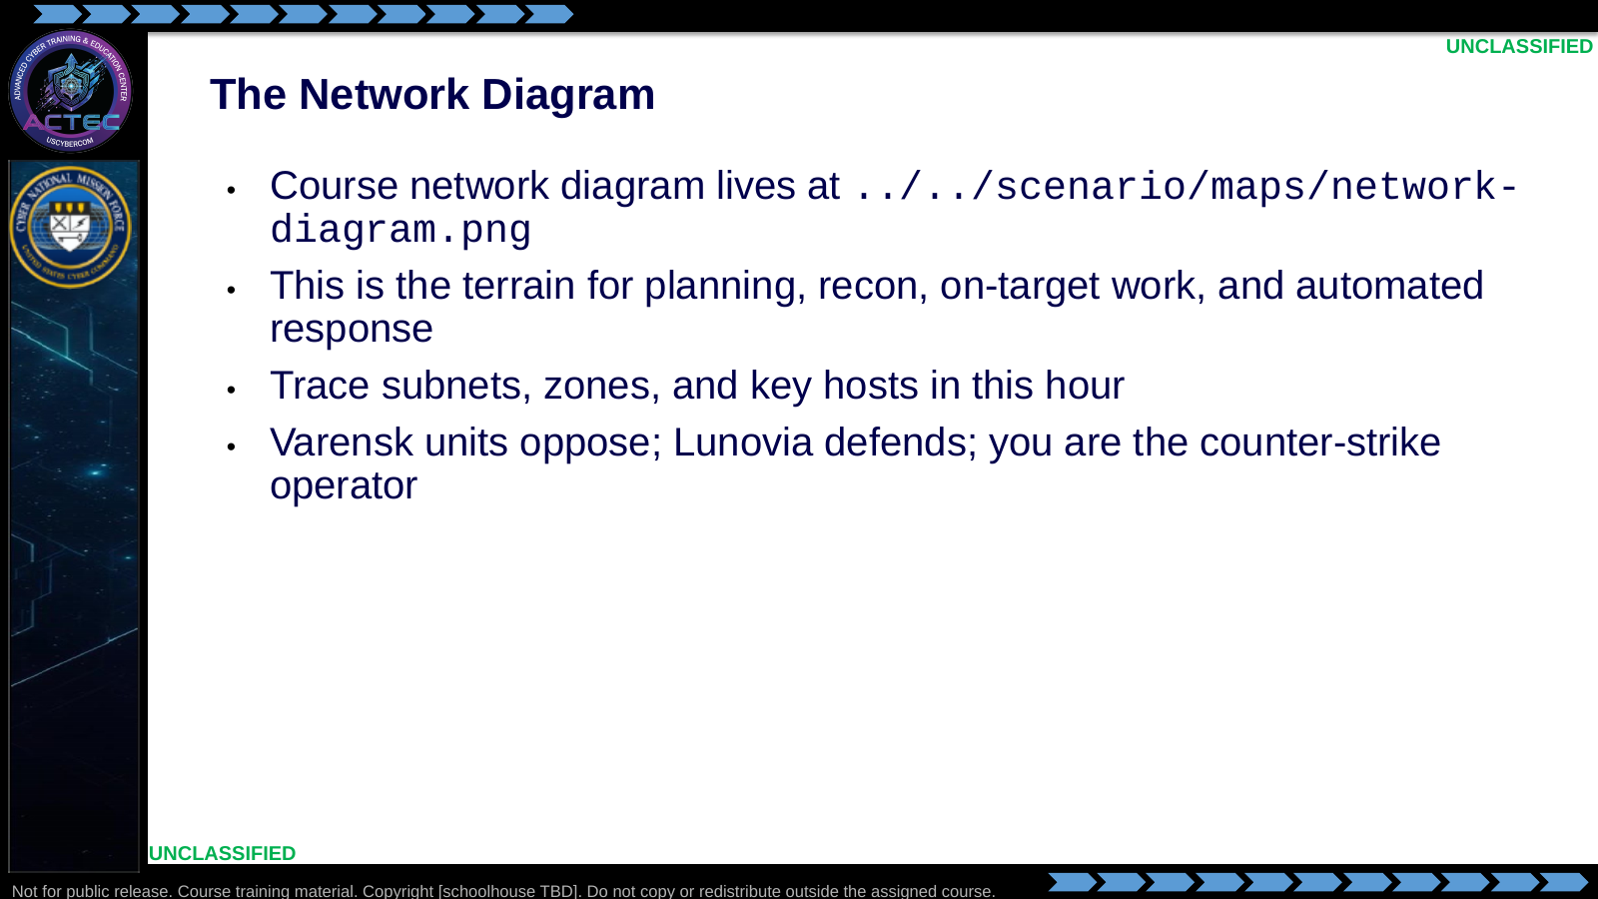  Slide 10: The Network Diagram  Duration: 9 min | Say: "Last slide. This is the network. Study it. Planning uses this terrain. Recon scans it. On-target work lives inside it. Agentic workflows automate against it. Varensk units are the opposition; Lunovia is the defender; you are the counter-strike operator."  Show: Project ../../scenario/maps/network-diagram.png full-screen. Walk subnets, zones, and key hosts.  Do: Give the room 5 minutes of quiet time to trace the diagram. Collect the questions — they seed later planning discussion.  Ask (Q): After tracing the diagram, write down three questions about this network.  Expected Response (A): Facilitation only. Collect questions; no target answers.

4.3 Lesson summary
- The course uses one fictional setting so every block shares a common target, terrain, and adversary without classification problems.
- Varensk is the authoritarian adversary: three cyber directorates (D7, EIS, ISB) and named units with C2 assignments and real-world analogues (Amber Tide / Gamaredon; Seraph-3 / Cozy Bear).
- Lunovia is the defender: NCDA, DIPC, foreign partnerships, and heavy cloud reliance. Blue team = Lunovia; DCO-RA out of blue-space = a Lunovian unit.
- The course network diagram is the terrain for planning, tradecraft, on-target, and agentic work.

4.4 Questions and check on learning
- Ask (Q): Why is the scenario fictional?
- Expected Response (A): Classification / attribution safety, and a common target-terrain-adversary for every block.
- Ask (Q): Name Varensk's three cyber directorates and one unit you will see again.
- Expected Response (A): D7, EIS, ISB. Accept any listed unit; Amber Tide and Seraph-3 are the analogues called out on Slide 6.
- Ask (Q): Which operational-environment elements on the Lunovian side will impact later planning?
- Expected Response (A): Steer toward cloud reliance, NCDA/DIPC structure, Lunovian Corridor / Vel River / Western Highlands, and the course network diagram as terrain.

5. Classification
Classification: UNCLASSIFIED

